Name：[Ghulam Mustafa]
Email：mustafabrohi874@gmail.com
This file contains report about three cryptocurreincies, Bitcoin (BTC), Etheruem(ETH) and BNB. Evaluating performance and risk over the past year.
TASK 2

Introduction
Bitcoin
Bitcoin is a decentralization crypto currency that can be bought and sold without the need of going to a financial institution. It was created by Satoshi Nakamoto in 2009, an electronic payment system based on cryptographic proof instead of trust. Since its launch the prices of Bitcoin (BTC) has risen dramatically in value. Many expect its price to only keep rising as time goes.
How does it work?
Bitcoin is built on a distributed digital record known as blockchain. Blockchain is a linked body of data, made up of units called blocks, that contain information about each transaction made, including time, date, total value, buyer and seller and a unique identity code for each transaction. The entries once made cannot be altered or faked, because its transparent and publicly available, because blockchain itself is decentralized, which means it’s not being controlled by any authority.

Ethereum
To expand blockchain’s potential beyond financial transactions, Ethereum was proposed in 2013 by Vitalik Buterin. Ethereum was launched in 2015 bringing new era of decentralized computing, enabling developers worldwide to create applications that operate without centralized control.
Ethereum, is a decentralized blockchain network, which is powered by cryptocurrency ether (ETH). Ethereum allows developers to create smart contracts and decentralized apps, enabling wide range of applications beyond just currency transfer.
In simple words, Ethereum stretches blockchain’s technology from decentralized transactions to decentralized developing and contracts.

BNB
BNB was created by Binance and launched in 2017 through an Initial Coin Offering (IOC), as an ERC-20 token on Ethereum. It’s the native cyrptocurrency of the BNB chain ecosystem, used for transaction fees, governance, staking and enabling wide range of application on Binance’s blockchain. BNB facilitates efficient blockchain transactions, fuels decentralized applications, and acts as multi-functional utility token.

Bitcoin
When first Bitcoin was introduced in 2009, it priced between $0.10-$0.15. Which gradually increased, currently one Bitcoin is worth about $68000 to $70000 as of Feb 2026.

Price trends
Bitcoin prices have fluctuated in the recent months, dropping from $95000 to $65000, which is quite depressive moment for the Bitcoin owners, causing panics and sudden drops in market cap, from 1.8Trillion USD to 1.2Trillion USD. Bitcoin has never faced this much drawbacks in the recent years, as of this year.
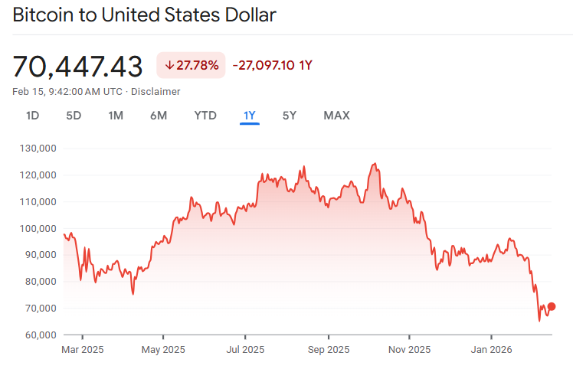
- The starting price in February 2025 is $97000, that shows high value and increasing market cap along with investor interest.
- The ending price as of February 2026 is about $70000, over the time this much gape in prices has created tension among Bitcoin holders, causing a price gape of around $27000.
- The lowest point in the year 2025 is during the 24th and 28th of February, where the price of Bitcoin drops from $98000 to $80000. The prices fluctuate around $80000 to $90000, from March to end of the April 2025.
- However, in the mid July 2025 the prices rise crossing $100000 per Bitcoin. The prices stay stable never going under $100000, instead it reaches up-to $120000+, during July and beginning of the October 2025.
- The highest point occurs in the Oct, where the price reaches up-to $123000+ marks the highest point in the year 2025.
- The prices from November to December drop to $123000 to $85000, and in the end of the year marking the closing the prices fluctuate around $84000 to $88000.
In conclusion, Bitcoin faced many ups and some serious downs in the previous year, causing tension and pressure in the crypto market. Though in the present, the Bitcoin is still at low price compare to its last year price in the current month.

In summary, investing in Bitcoin can be profitable if it’s done for long-term purposes. It performs very reliably and holds strong in the market, mostly in long-term. For short-term Bitcoin can be risky, because it shows significant ups and downs over the past 12 months. The trends show high fluctuations, show casing high risk.
In conclusion, based on the insights Bitcoin can be a reliable investment in long-term goals, often beating up past price trends.
Ethereum
Ethereum was introduced in 2013 and launched in 2015, the starting price of Ethereum was approximately $0.74. Over the years its price fluctuated significantly rising and falling in between. Currently its price is about $1996, with market cap of $236.78 billion USD.

Price Trend
In the recent months price of Ethereum has not been quite stable, fluctuating and dropping from high to low. In mid of January and start of February 2026, its price dropped from $3300 to $1800, marking a low point in the starting of the year.
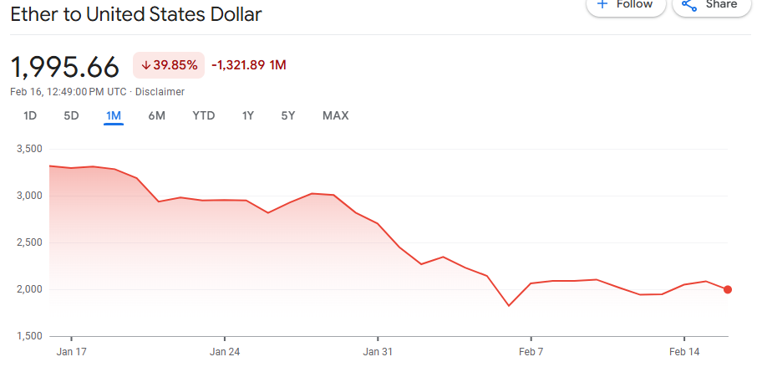
The above chart shows performance of Jan and Feb 2026.

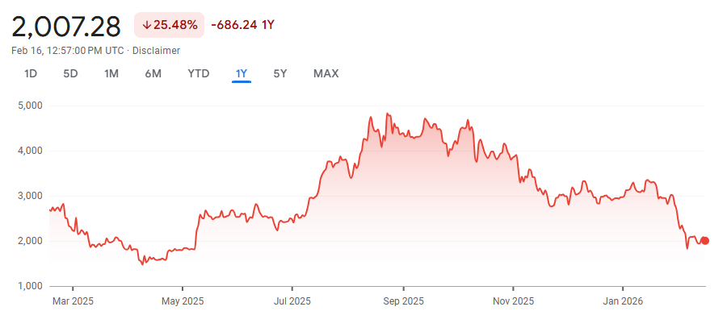
- As we can see that the above chart shows one year of performance of Ethereum, showing ups and downs.
- The starting price of Ethereum is about $2500 to $2650, marking a stable performance from February to start of March.
- Prices start to fall in mid of March, dropping from $2200 to $1600, and fluctuating around $1800, marking a bearish moment.
- Ethereum achieves stability in the mid of May, instantly rising from $1800 to $2500, creating a bullish moment. The prices stay stable between May and starting of July.
- Ethereum achieves hype in between mid of July and the end of January 2026.where the prices rise in between marking a strong bullish moment, from $2500 to $4800, and staying stable around $3000 to $3900 in the end of January 2026.
- Though closing year price stays around $2900 to $3000, which represent a strong performance.
In conclusion, performance of Ethereum was good enough, starting from $2500 and reaching a high of $3900. Which represents stability and investor interest. Though in the starting of 2026 it declined and went from $3000 to $2000 going -$500 from starting point of 2025.
In Conclusion, Ethereum’s price movement in 2025 and early 2026 shows both growth and risk. The asset rose from about $2500 to nearly $3800, but also dropped sharply to $1600 in March and later to $2000 at the start of 2026. Short periods of stability, such as mid-2025 and late-year ranges around $3000–$3900, did not last long, showing how fragile the market can be. Much of the rise was driven by hype and investor mood rather than lasting fundamentals, which makes sudden declines more likely. Overall, Ethereum showed strong investor interest, but its high volatility and dependence on sentiment mean that investing requires caution, good timing, and risk control.
BNB
When BNB was introduced in 2017 it priced $0.10 per token, over the years it has risen from $0.10 to $626, having a market cap of $83.30 billion USD.
Price Trend
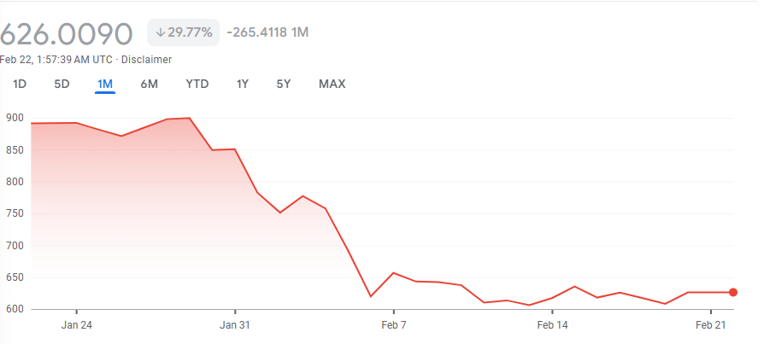
The price trend of BNB shows a drop in the end of January and beginning of the February 2026, going from $900 to $620, show casing a bearish moment in the new year’s starting.
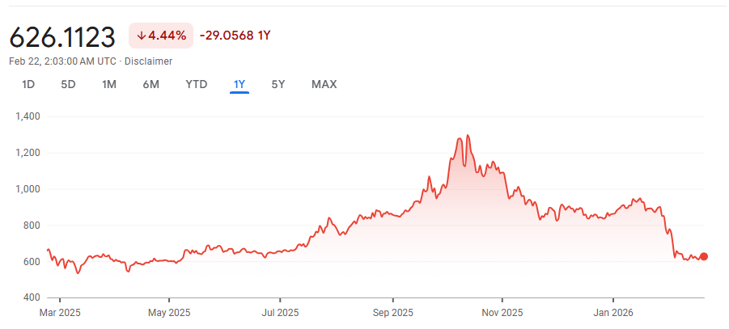
This chart shows performance of BNB in January and February 2026, representing the drop and volatility.
- The starting price of BNB was around $600–$620, showing a relatively stable performance during the early months.
- From late spring to mid-year, prices moved gradually upward, indicating positive momentum and increasing investor interest.
- Between late summer and early autumn, BNB experienced a strong bullish movement, with prices rising sharply and reaching a peak of approximately $1,250–$1,300.
- After reaching its peak, the price entered a market correction, declining steadily from around $1,200 to $850, reflecting increased volatility and selling pressure.
- In the later months, prices showed short-term stabilization around $850–$950, followed by a sharp decline toward the end of the period.
- The closing price returned to around $620, resulting in an overall negative annual performance despite strong mid-year gains.

Overall, BNB demonstrated a mixed and highly volatile performance over the 12-month period. Although the asset experienced strong price appreciation during the mid-year bullish phase, these gains were not sustained, leading to a sharp year-end correction. This price behavior reflects a high-risk, speculative investment profile.
From a risk management perspective, investors should limit exposure to BNB through appropriate position sizing and avoid over-concentration in a single asset. Diversification across other cryptocurrencies or asset classes can help reduce overall portfolio risk. Additionally, the use of stop-loss strategies may assist in managing downside risk during periods of high volatility.

